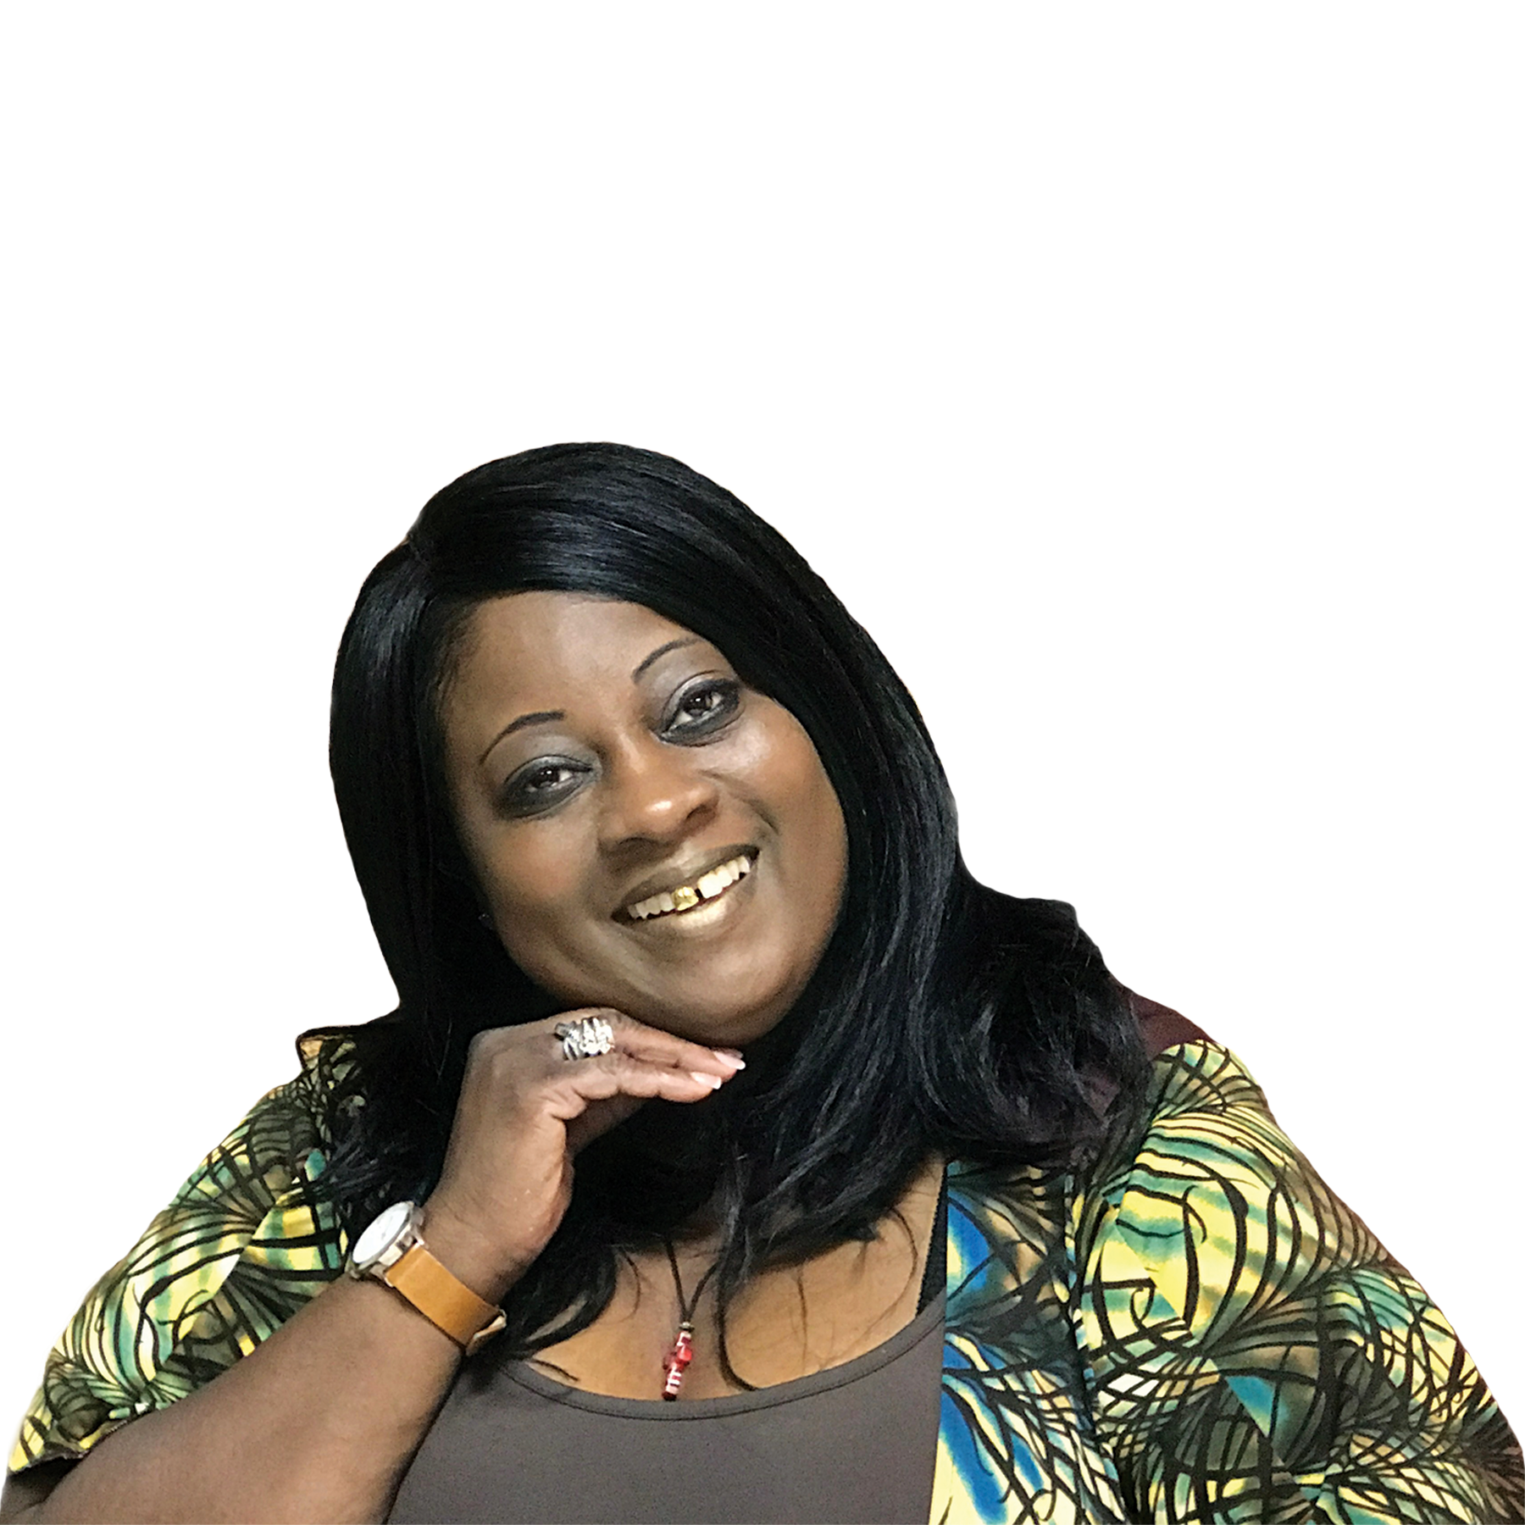
Break Free Release Ministries
430 Highway 6 South
Suite 206
Houston Texas 77079
Phone: 832-263-8759
EVENT INFORMATION FORM
Host Ministry Telephone
Name of Senior Pastor Spouse
Ministry Address City/St/Zip
Address of Banquet City/St/Zip
Crusade Coordinator Contact Phone
Coordinator Address Cell Phone
Crusade will be held on the following days M T W Th Sa Su
Time worship service is scheduled to begin AM PM
Crusade Theme AM PM
Seating Capacity/Expected Attendance
Special Guests Attending
Time Praise & Worship will begin Offertory Period Time
Allotted Speaking Time for Prophetess Sherman
Special Attire (Circle One) Robe Full Band Roman Collar Suit
ACCOMMODATIONS
Name of Hotel Phone Number
Hotel Address Fax Number
Number of Rooms
Distance from the Airport Distance from Hotel to Venue
Weather Conditions for this Season
Additional Information

Break Free Release Ministries
430 Highway 6 South
Suite 206
Houston Texas 77079
Phone: 832-263-8759

CRUSADE INFORMATION SHEET
- Prophetess Sherman usually travels by coach. Your responsibility will be for the one coach class ticket.
- Prophetess usually returns the same night but if she remains overnight please provide one (Non Smoking Suite) with a King Size Bed.
- If possible, please make arrangements for a representative to meet Prophetess Sherman at the airport gate. We will need assistance in this area.
- Please have Prophetess Sherman’s hotel room key available for her upon her arrival. After traveling a long distance, we would like to immediately get Prophetess Sherman to her hotel room without having to stop or wait at the hotel desk.
- Please provide a full-sized or luxury vehicle for pick-up from the airport. Prophetess Sherman normally travels light, but we still need large passenger/ trunk space.
- In preparation for ministry, Prophetess Sherman prefers quiet time in her hotel room during the day.
- Prophetess Sherman does not request a specific honorarium; we believe that a Ministry of your caliber will be fair.
- For Crusades, Revivals and events in which we will drive, we request a reserved parking space close to the venue/entrance.
- Prophetess Sherman prefers to drink room temperature water or hot beverage before and after she ministers.

